**Scope of Project**

1. General shop that will cover all kinds of grocery & and food items.
2. A variation will be specialized for the furniture Industry.

**General Concept/Requirements for Development**

1. Cashing System
2. Cashing on/Off from the front end
3. CDN System (Aws/Azure)
4. Should have a plugin installation & and an on/Off system
5. Demo Mode Active/Inactive
6. Translation
7. Left To Right Option
8. Admin Option to central/vendor/Mixed Item, if central then the store will not able to add any item.
9. Central Date Format Option
10. **Introduction**

***1.1. Purpose***

***1.2. Dynamic Futures Overview***

***1.3. Scope of Project***

1. **Overall Description**
   1. ***System Environment***
   2. **CMS Variations (Product Concept)**

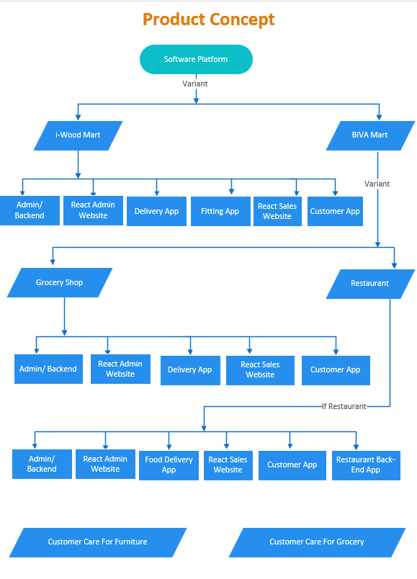

* 1. ***Functional Requirements Specification***

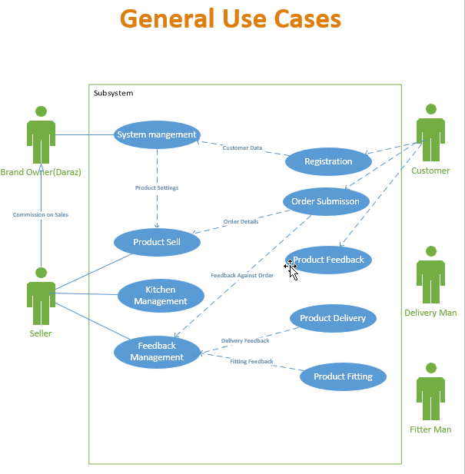

* + 1. **Brand Owners (like Daraz) use case**
    2. **Vendor Use Case**
    3. **Customer Use Case**
    4. **Delivery-Man/Fitter-Man Use Case**
    5. **Restaurant (Kitchen) Use Case**
    6. **User Use Case**

**#designtemplate_sp**

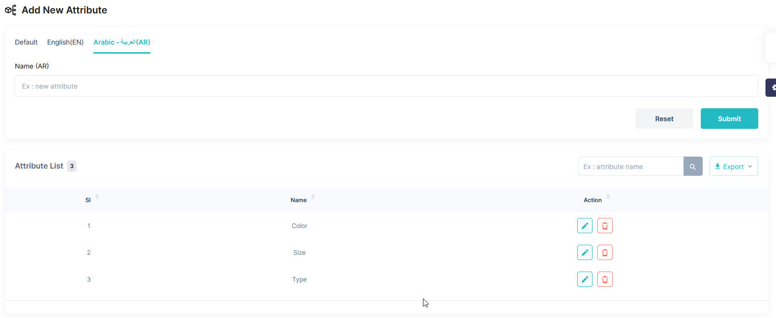

1. ***Non***-***Functional Requirements***
   * 1. ***Architectural***
2. The BIVA-MART shall be designed with a Service Oriented Architecture (SOA).
3. The BIVA-MART shall be built so that it can follow Representational State Transfer (REST).
4. The BIVA-MART must be designed with a Modal‐View‐Controller (MVC) architecture.
5. The BIVA-MART must use open-source programming technology.
6. The BIVA-MART code shall build on Test Driven Development (TDD)
   * 1. ***Documentation***
7. The MIS shall have a hardcopy user guide that explains all the functions.
8. The MIS shall have an online user guide that explains the functions of the System.
9. **Requirements Specification**
   1. **External Systems**

MIS systems need to handle data connection with legacy systems and other peripheral systems, which are:

1. **Legacy System**: The current legacy system has a database that can be any time, and all its data must be restored completely

2. **Online System**: it is used to select students based on specific criteria, our system can connect with the database and restore data

3. **Portal**: this portal will show success stories and achievements that can bind with our system through API

4. **Students Apps**: in the future, there will be apps that can help students with specific purposes, the system can be expanded to do these tasks.

* 1. **Online Selection Website Functional Requirements**
  2. **Add Product Attribute (**Table: product_attribute, product_attribute_line**)**

|  |  |  |
| --- | --- | --- |
| Form Style | **:** | Single Form |
| Title | **:** | Add New Attribute |
| Description | **:** | All product-related attributes will be stored here. |
| Actor | **:** | Admin |
| Preconditions | **:** | Column “attribute_type “will be used only in the furniture sector. |
| Postconditions | **:** | There should be an option to add value for newly added attributes. Ex: Size (XL,XXL, Large) |
| Triggers | **:** |  |
| Basic Flow | **:** | |  |  |  | | --- | --- | --- | | Field Name | Title | Description | | attribute_name | Name(Lang) | Name of The attribute | | attribute_type | Type | 1. Fabric 2. General, the Primary target is to use in the furniture sector. | | sub_items_count | Hidden field | Count of sub-item (line). Will be managed from backend | | Field Name | Title | Description | | attribute_line_name | Name(Lang) | Sub value Ex. XL,XXL. This will appear for select once select the master attribute. | |
| Alternative Flow | **:** |  |
| Exception flows | **:** |  |

* 1. **Add Product Group (**Table: product_attribute, product_attribute_line**)**

|  |  |  |
| --- | --- | --- |
| Form Style | **:** | Single Form |
| Title | **:** | Add New Attribute |
| Description | **:** | All product-related attributes will be stored here. |
| Actor | **:** | Admin |
| Preconditions | **:** | Column “attribute_type “will be used only in the furniture sector. |
| Postconditions | **:** | There should be an option to add value for newly added attributes. Ex: Size (XL,XXL, Large) |
| Triggers | **:** |  |
| Basic Flow | **:** | |  |  |  | | --- | --- | --- | | Field Name | Title | Description | | attribute_name | Name(Lang) | Name of The attribute | | attribute_type | Type | 1. Fabric 2. General, the Primary target is to use in the furniture sector. | | sub_items_count | Hidden field | Count of sub-item (line). Will be managed from backend | | Field Name | Title | Description | | attribute_line_name | Name(Lang) | Sub value Ex. XL,XXL. This will appear for select once select the master attribute. | |
| Alternative Flow | **:** |  |
| Exception flows | **:** |  |

* 1. **Add Brand Name (**Table: product_brand**)**

|  |  |  |
| --- | --- | --- |
| **Form Style** | **:** | Single Form |
| **Title** | **:** | **Admin Form**: Add New Brand, **Seller Form**: Verify Brand Information |
| **Description** | **:** | There will be two forms, One for admin, and another for seller. The seller will request if no brand is available. |
| **Actor** | **:** | Admin, Seller |
| **Preconditions** | **:** |  |
| **Postconditions** | **:** |  |
| **Triggers** | **:** |  |
| **Basic Flow** | **:** | |  |  |  | | --- | --- | --- | | Field Name | Title | Description | | brand_name | Brand Name | Brand Name | | display_order | Display Order | Order to display brands | | brand_slug | Walton | Walton-hi-tech-industries | | brand_logo | Logo | Logo from gallery | | meta_title | Meta Title | Manual entry of meta title for SEO | | meta_description | Meta Description | Manual entry of meta description for SEO | | seller_relation_with_brand | Relationship with the Brand | Four Options:  Brand Owner  Exclusive Distributor  Non Exclusive Distributor  Reseller | | authorization_valid_from | Authorization Validity  Start From | Applicable for distributor/reseller | | authorization_valid_to | To | Can be null, which means never expired | |
| **Alternative** **Flow** | **:** |  |
| **Exception** **flows** | **:** |  |

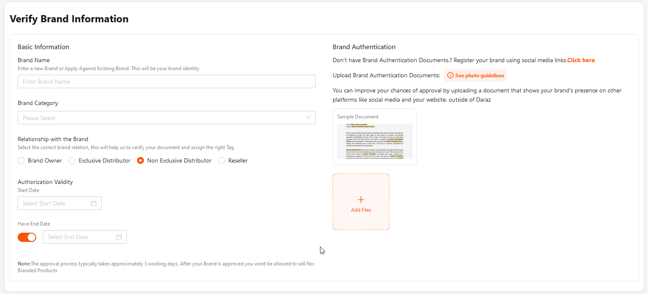

* 1. **Add Brand Name (**Table: product_brand**)**

|  |  |  |
| --- | --- | --- |
| **Form Style** | **:** | Single Form |
| **Title** | **:** | **Admin Form**: Add New Brand, **Seller Form**: Verify Brand Information |
| **Description** | **:** | There will be two forms, One for admin, and another for seller. The seller will request if no brand is available. |
| **Actor** | **:** | Admin, Seller |
| **Preconditions** | **:** |  |
| **Postconditions** | **:** |  |
| **Triggers** | **:** |  |
| **Basic Flow** | **:** | |  |  |  | | --- | --- | --- | | Field Name | Title | Description | | brand_name | Brand Name | Brand Name | | display_order | Display Order | Order to display brands | | brand_slug | Walton | Walton-hi-tech-industries | | brand_logo | Logo | Logo from gallery | | meta_title | Meta Title | Manual entry of meta title for SEO | | meta_description | Meta Description | Manual entry of meta description for SEO | | seller_relation_with_brand | Relationship with the Brand | Four Options:  Brand Owner  Exclusive Distributor  Non Exclusive Distributor  Reseller | | authorization_valid_from | Authorization Validity  Start From | Applicable for distributor/reseller | | authorization_valid_to | To | Can be null, which means never expired | |
| **Alternative** **Flow** | **:** |  |
| **Exception** **flows** | **:** |  |